Adrian Burnett Elementary School

Kindergarten Supply List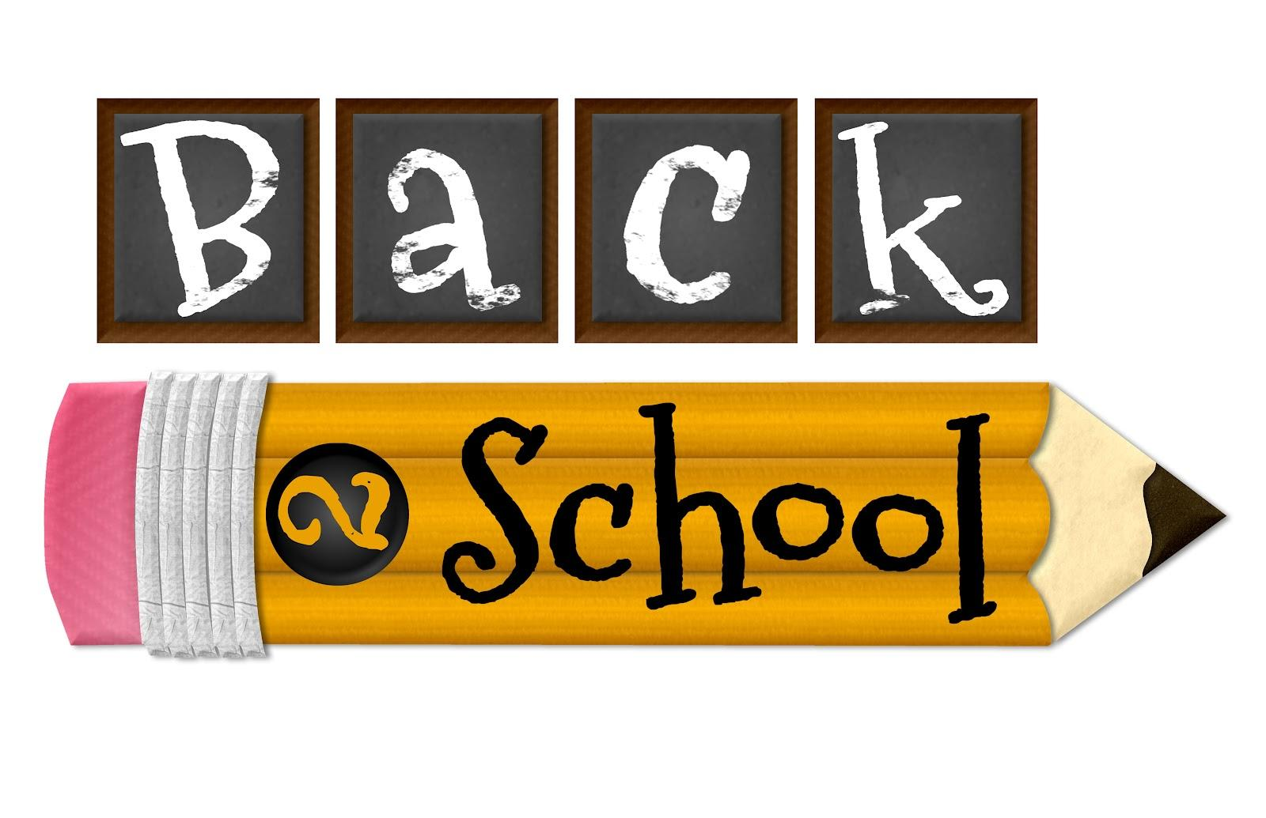

2025 – 2026

4521 Brown Gap Road - 865-689-1474

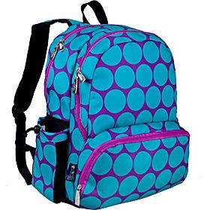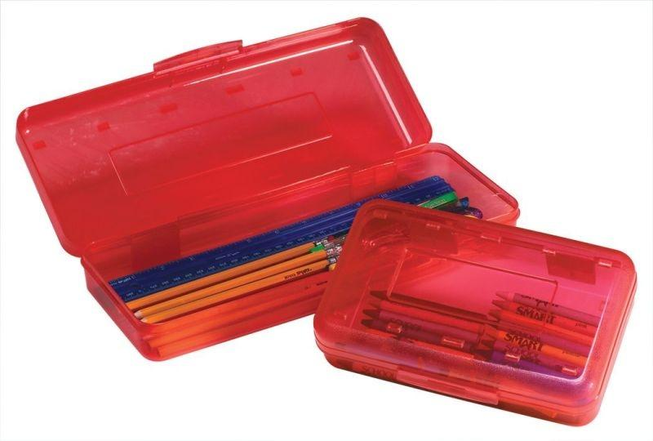

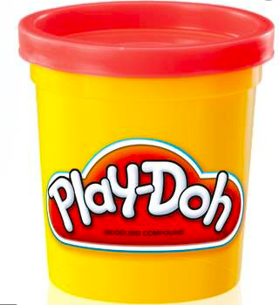

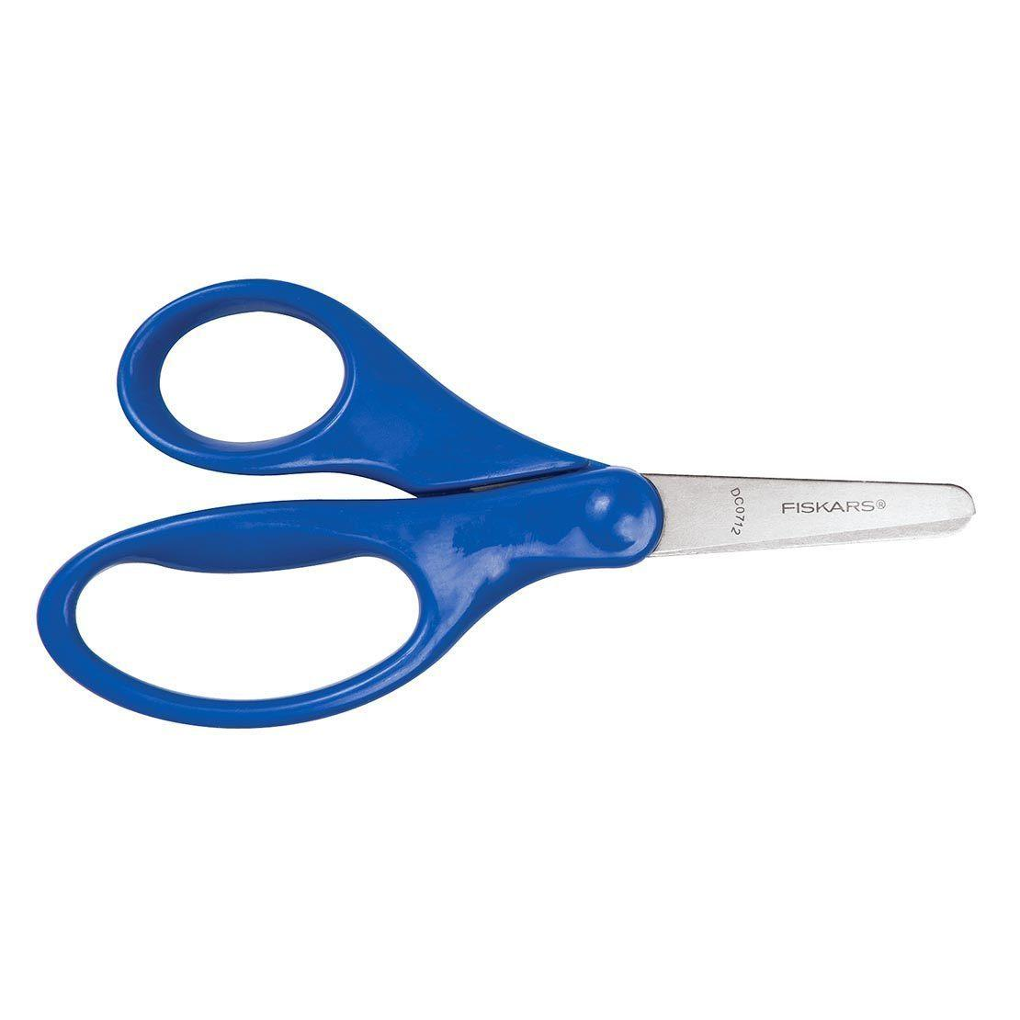

1 backpack (no wheels) 1 plastic pencil box 1 can of Play-Doh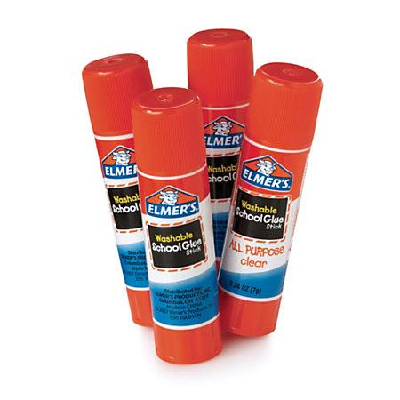

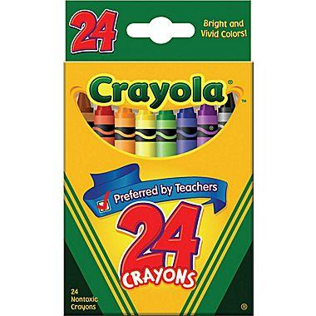

4 packs Crayola crayons 1 pair Fiskar scissors 8 (or more) glue sticks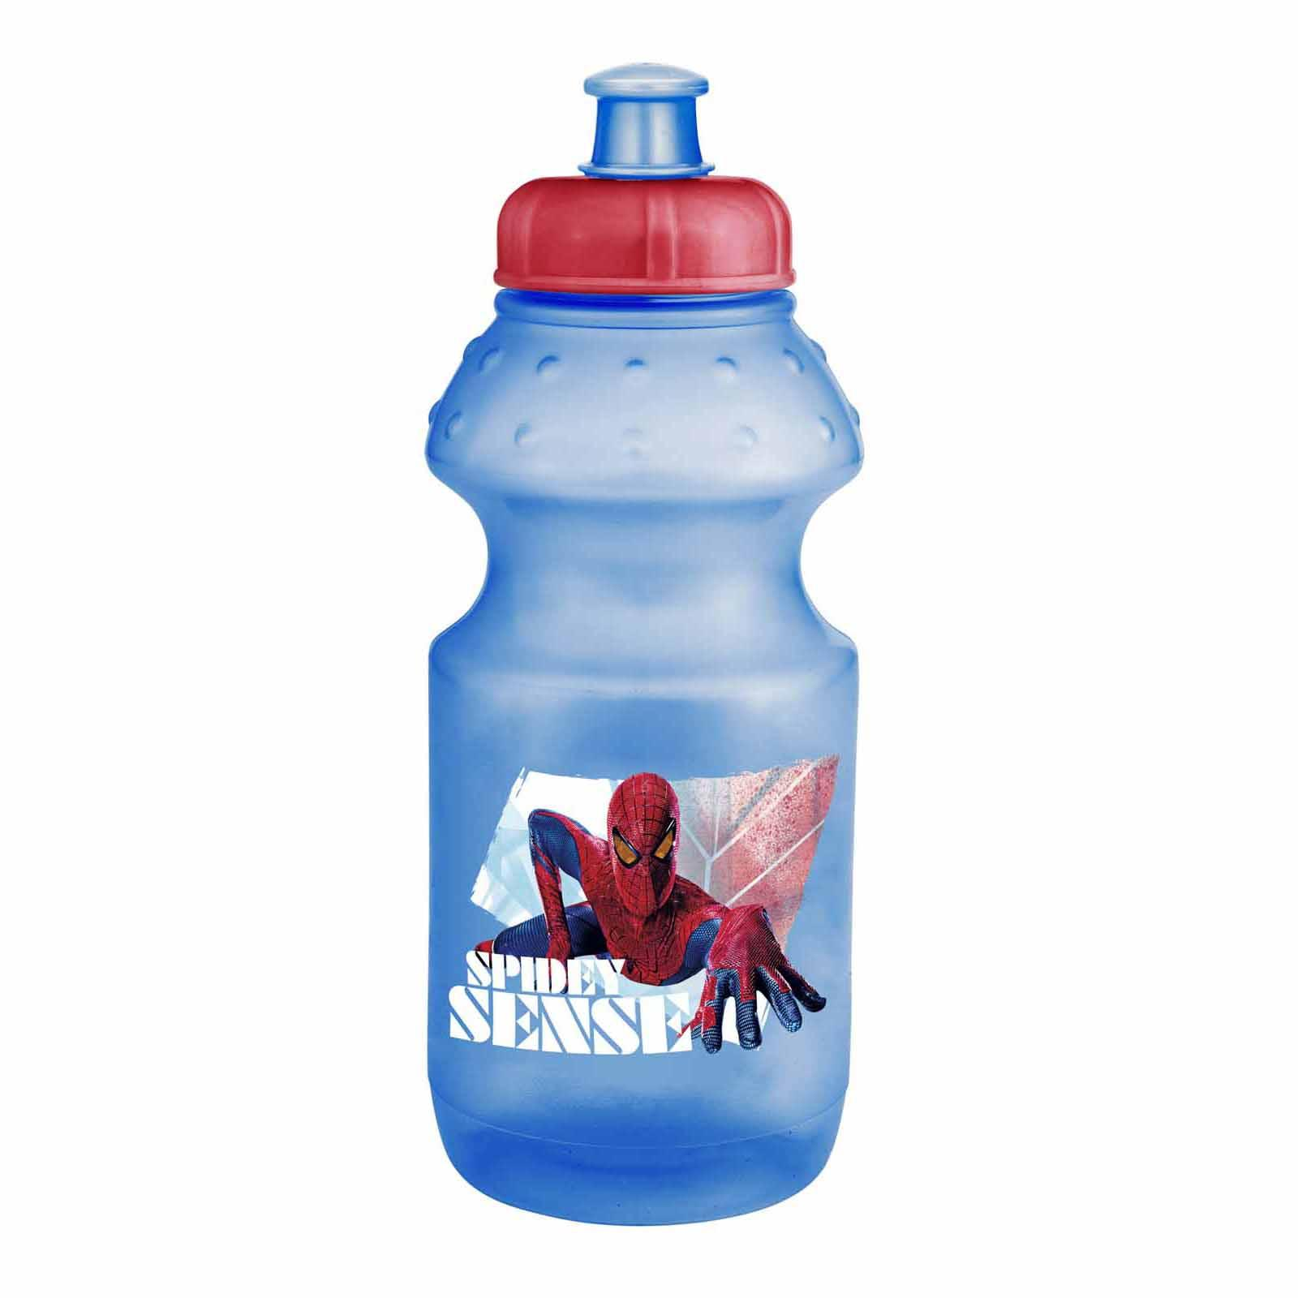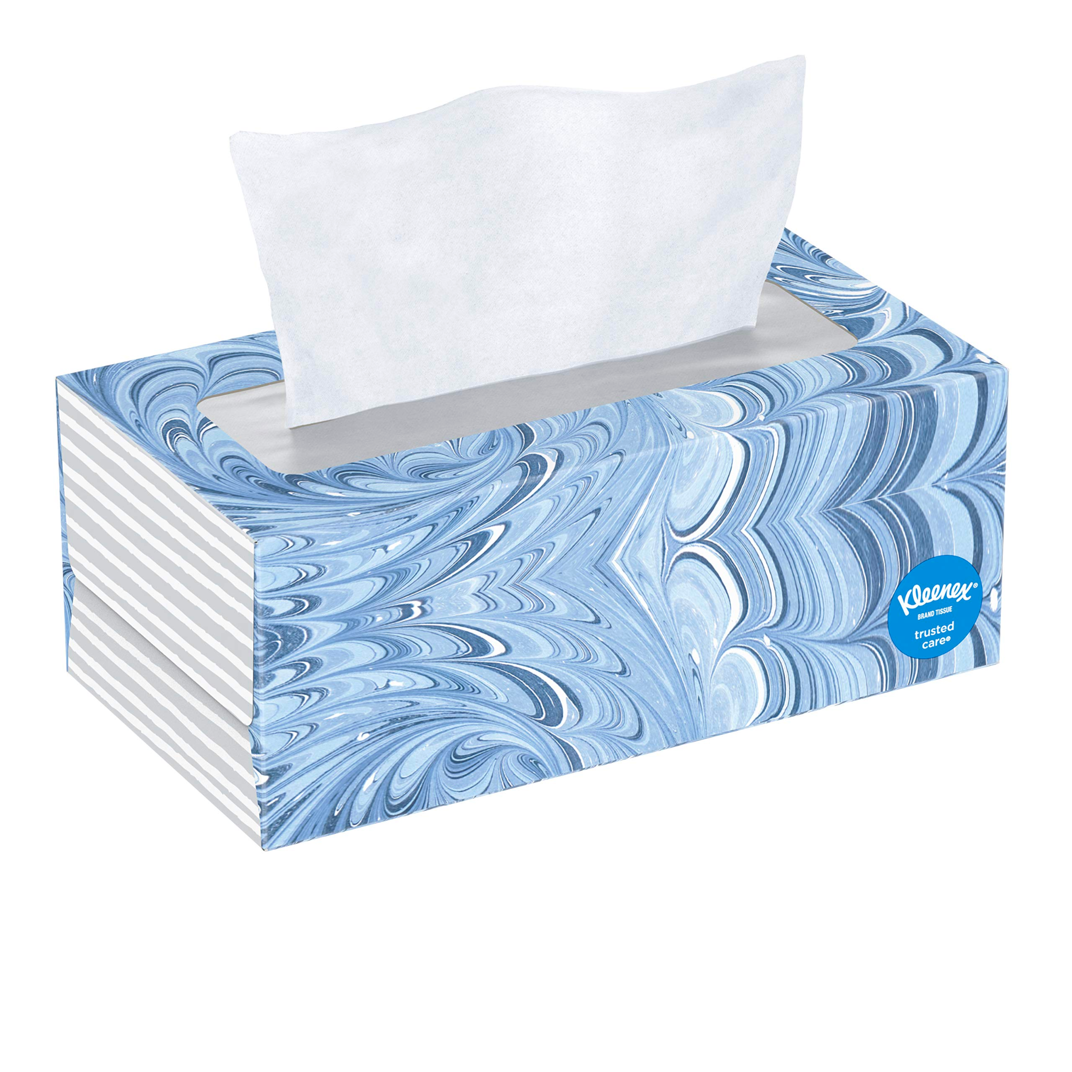

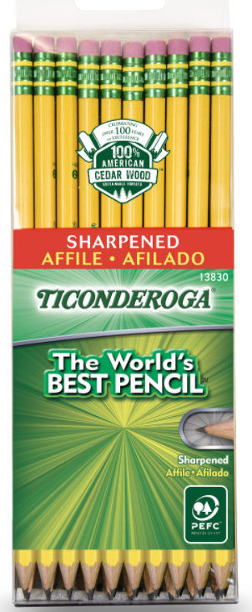

1 Box Tissues 1 water bottle

(labeled with name). SHARPENED Pencils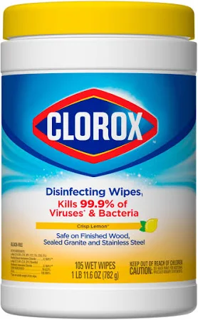

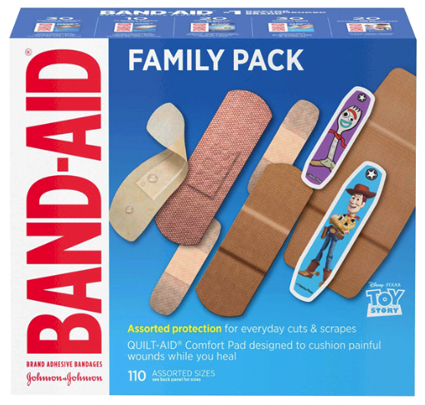

Clorox wipes Bandaids

**OPTIONAL** (Things we would love to have if you are able to send them!)

white cardstock Baby wipes Extra Play-doh

Paper towels markers Treasure box toys

Ziplock bags Elmer’s white glue